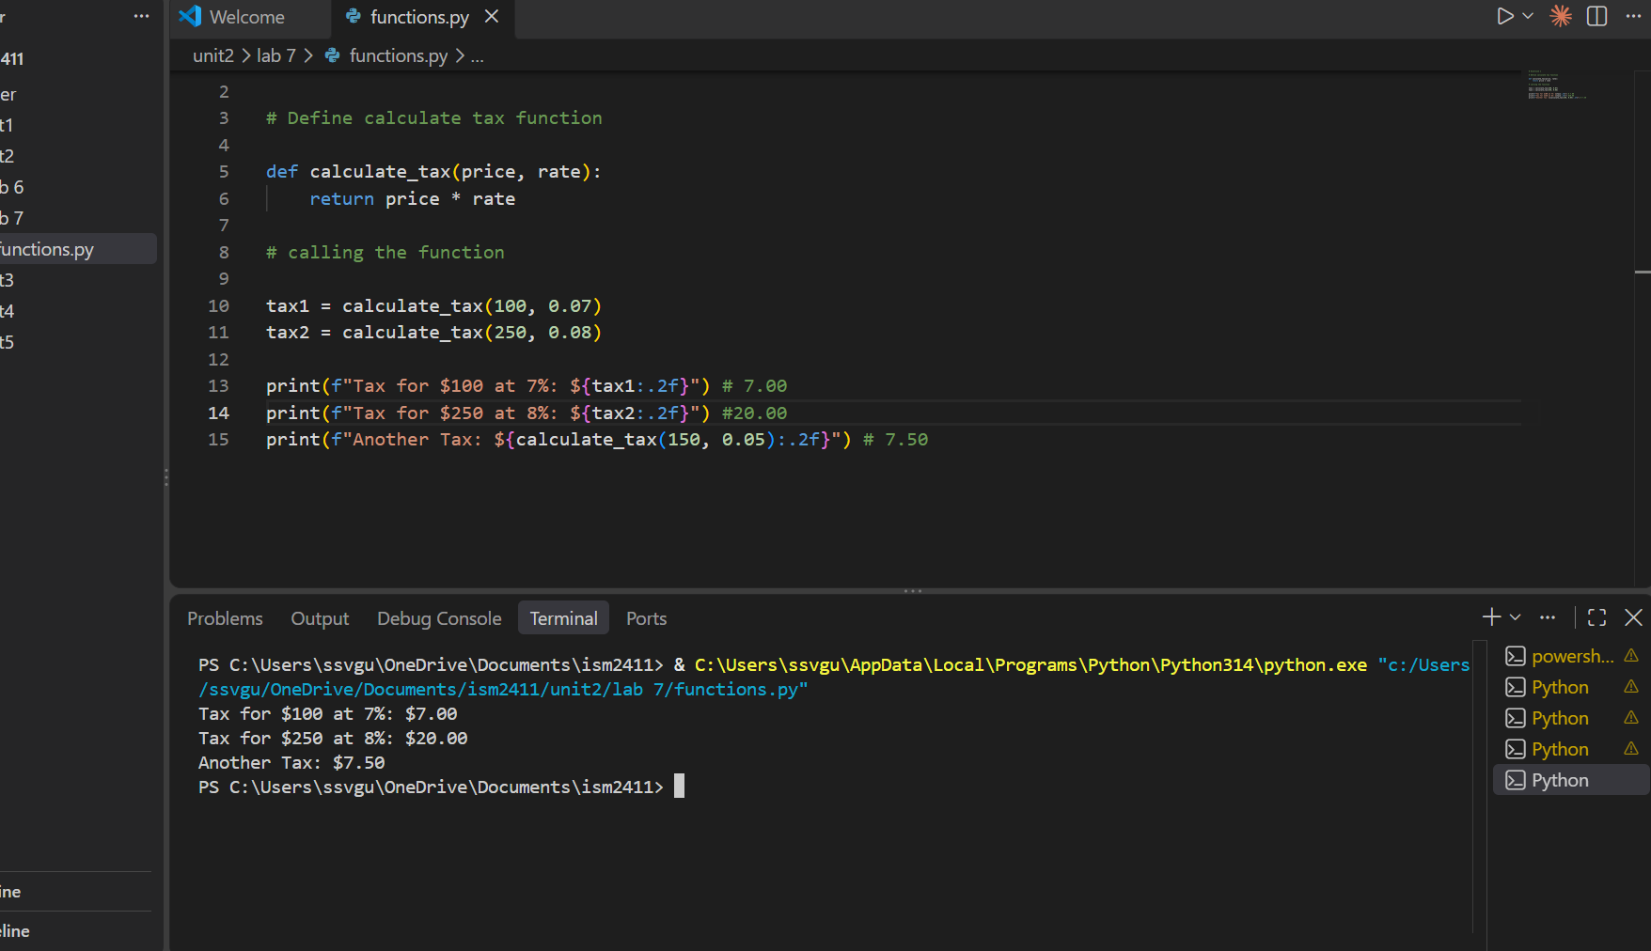

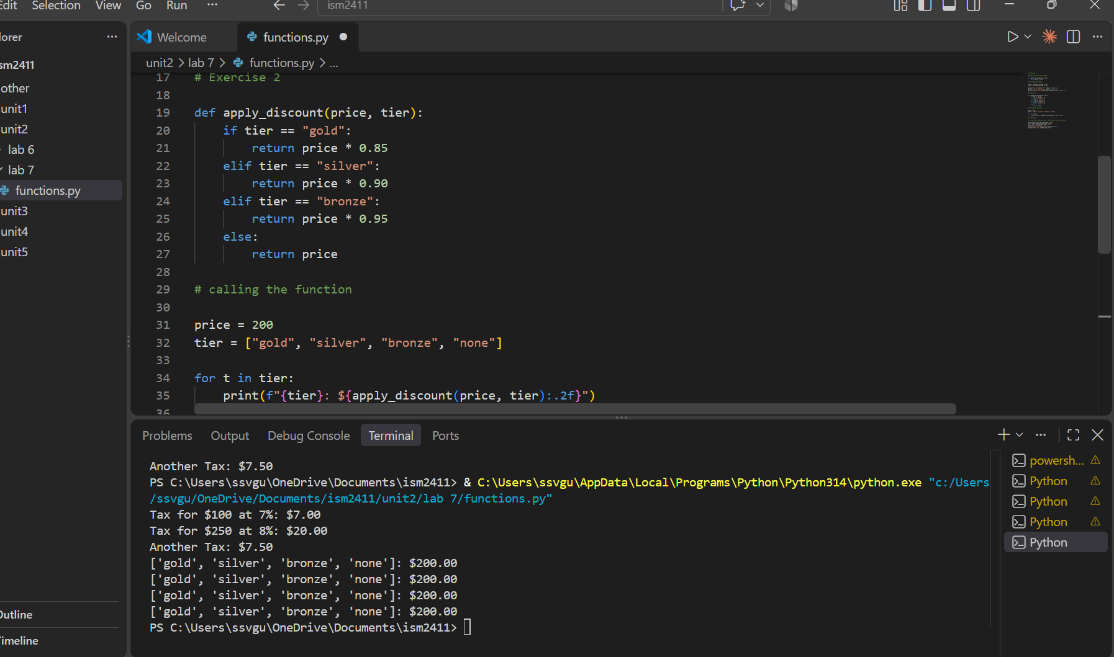

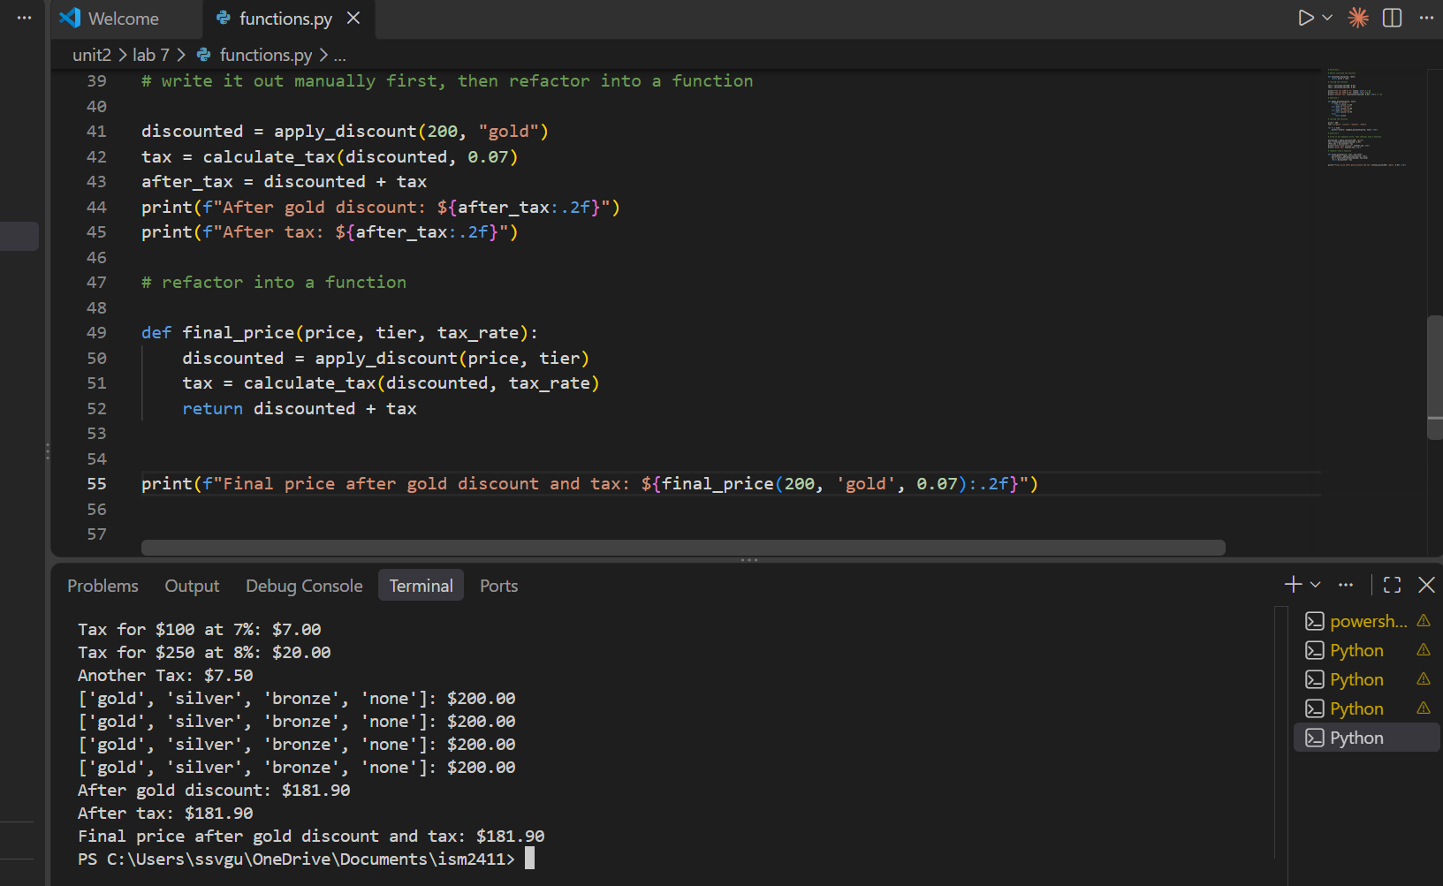

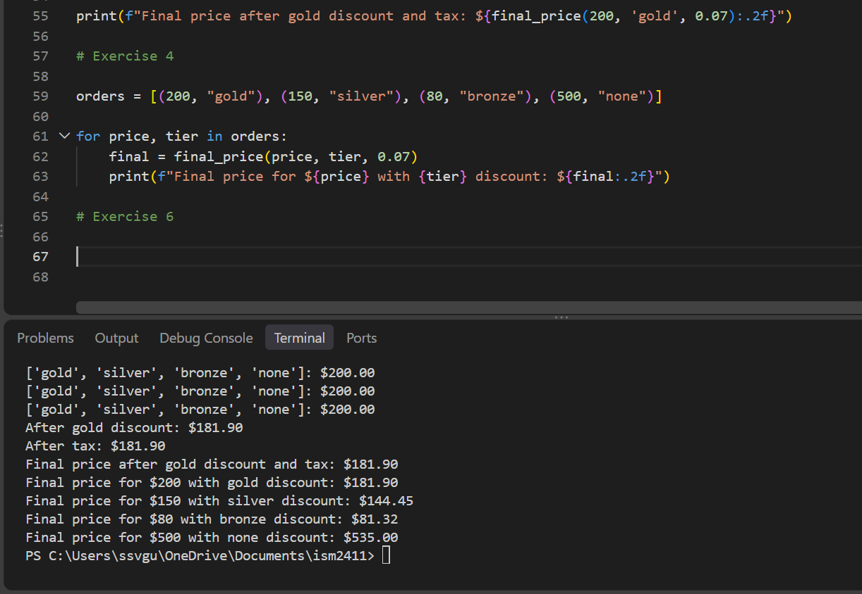

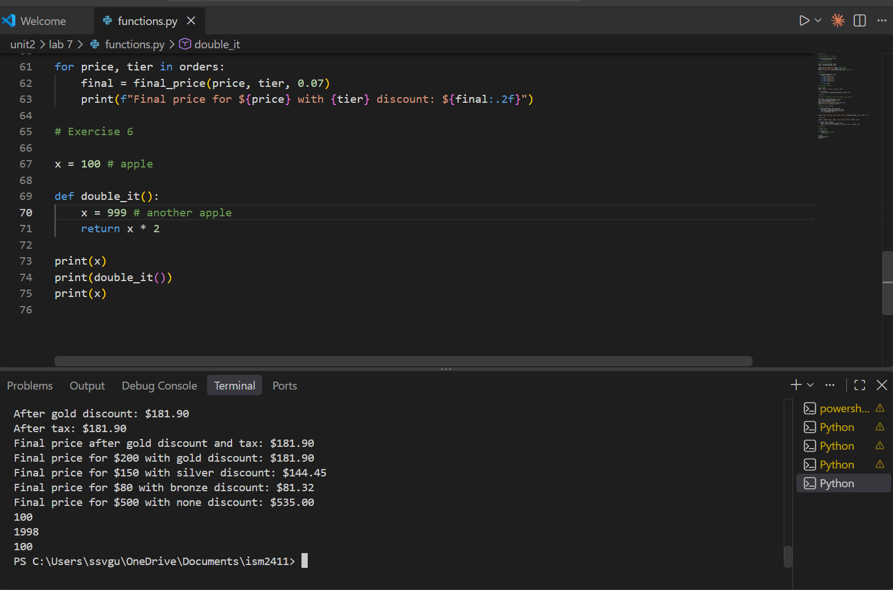

Excersize 5:
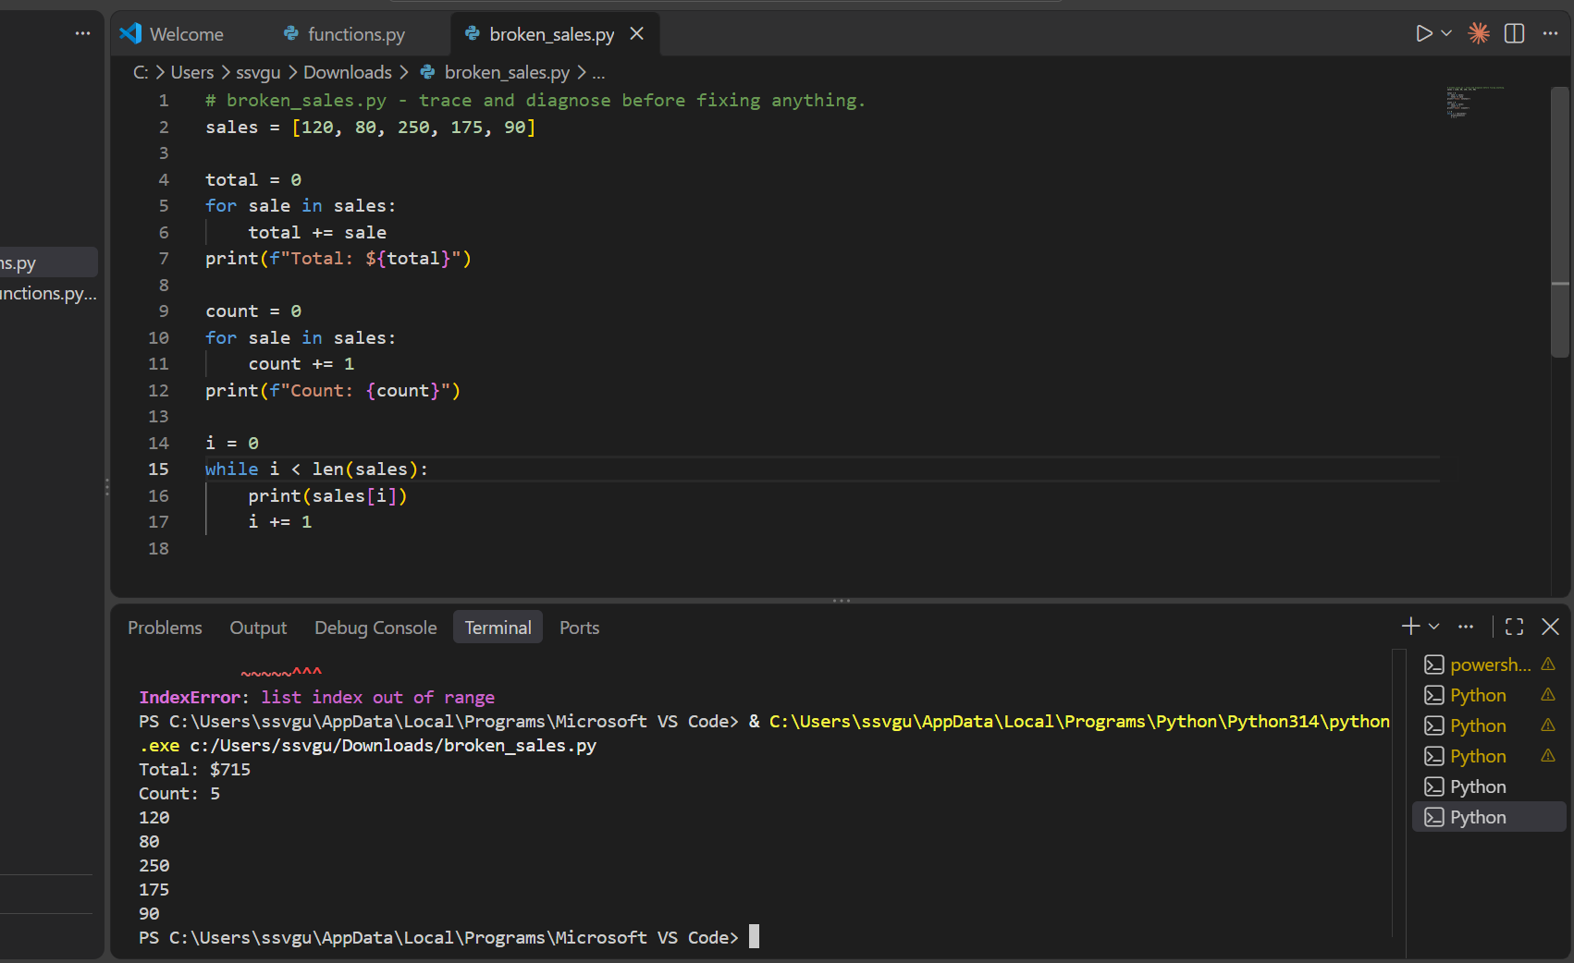

Self Assesment questions:
1. The first bug I caught was from the traceback. It showed me exactly where the code broke, and that helped me fix it. It made me realize I’m starting to rely more on reading errors instead of guessing.
2. apply_discount(price, tier) takes a price and a discount tier, figures out how much money to take off, and returns the new price. Someone else could use it without reading the code because the name explains what it does.
3. AI disclosure comment: # AI Disclosure: I used AI for guidance, but all final code and understanding are my own.

